C++ :: std vector/ list/ map/ set/ priority queue

Vector
Common method:
vector<int> v;
vector v(10, 0); // {0,0,0,0,0,0,0,0,0,0}
v[i] // access element at index i
v.size() // return number of element
v.clear() // erase all element
v.empty() // return True/False, any element in v or not
v.erase(it ) // delete the element at position it, O(n) complexity since all
//element after it need to arrange
v.insert(it, val) // insert val at position it, O(n) complexity
v.push_back(val) // add element val at end of vector, O(1) complexity
v.pop_back() // return element at end
v.begin() // the iterator at the front
v.end() // the iterator at the end
lower_bound( it_begin(), it_end() ) also takes O(n)
Other idea:
- Better use v.empty() to check if there is any element in vector (don't use v.size()).
Most of time it is ok for vector. Takes O(1) complexity to v.size(). But v.size() for list takes O(n) complexity.
- In vector, the difference between size and capacity?
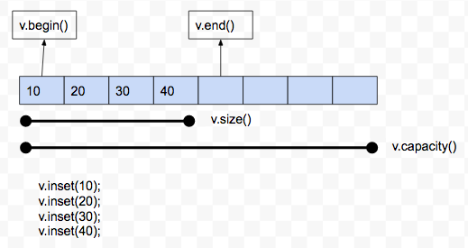

- There are many approach when we aim to copy one vector to another.
http://workhahard.blogspot.com/2016/04/c-vector.html
1. one by one by for loop
for(int i=0;i<v.size();i++)
v2[i] = v[i]
2. vector.assign()
v2.assign(v.begin(), v.end())
3. reserve
v2.reserve(v.size())
v2.insert( v2.end(), v.begin(), v.end())
4. constructor
v2 = vector(v)
- It is common when you get a vector from address reference and don't want to change the original value, for example:
vector<vector<int>> permute(vector<int>& nums) {
copy nums to vectorTmp
...
}
- Difference between Vector and List:
https://stackoverflow.com/questions/2209224/vector-vs-list-in-stl
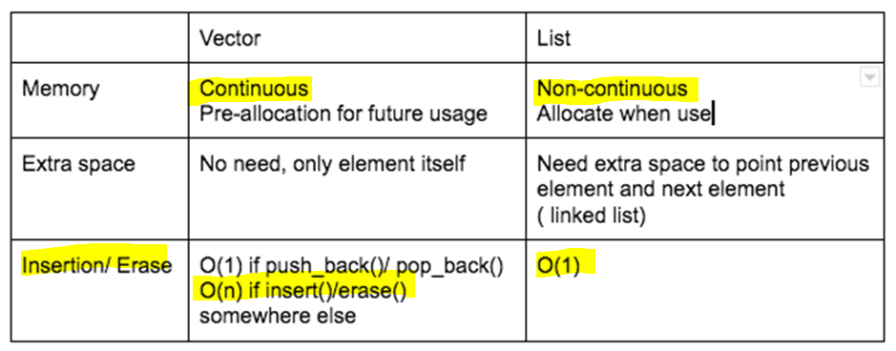

List
Common method:
list<int> li;
li[i] // access element at index i
li.size() // return number of element
li.clear() // erase all element
li.empty() // return True/False, any element in v or not
li.erase(it ) // delete the element at position it, O(1) complexity since all
//element after it need to arrange
li.insert(it, val) // insert val at position it, O(1) complexity
li.push_back(val) // add element val at end of vector, O(1) complexity
li.pop_back() // return element at end
li.begin() // the iterator at the front
li.end() // the iterator at the end
li.front() // Returns the value of the first element in the list.
back() //Returns the value of the last element in the list.
push_front(g) //Adds a new element ‘g’ at the beginning of the list.
pop_front() //Removes the first ele of the list, and reduces size of the list by 1.
list rbegin() and rend()
rbegin() returns a reverse iterator which points to the last element of the list.
rend() returns a reverse iterator which points to the position before the beginning of the list.

The STL list is a standard doubly linked list. It supports constant-time insertion and deletion of elements at any point in the list, but provides slow (linear) time access to individual elements. In fact, the list does not even provide random access operations like operator[].

Map
Composed of nodes, each node is a pair of {key, value}. Key in unique in each map.
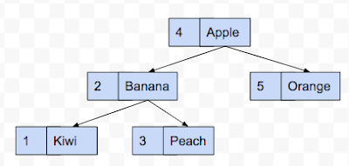
Two container are support as a map in C++
map<int, string> m;
Implement by Red-Black tree ( insertion()/ find()/ and delete() takes O(logn) lower_bound( it_begin(), it_end() ) also takes O(logn))
unordered_map<int, string> m2;
Implement by hash table (insertion()/ find()/ and delete() takes O(1), but require huge extra space)
Common method:
m.insert(pair<int, string>(100, "Watermelon")) // insert/replace a node
m[200] = "StrewBerry" // insert/replace by array
auto it = m.find("Apple") // return the iterator of node which value = "Apple"
if( it!= m.end()){
cout << it -> second // return value = pari< key, value>
}else{
cout << "can't find"
}
m.count( x) // return 1 if this map contain node with key = x, o otherwise
begin() – Returns an iterator to the first element in the map.
- end() – Returns an iterator to the theoretical element that follows the last ele in the map.
- size() – Returns the number of elements in the map.
- max_size() – Returns the maximum number of elements that the map can hold.
- empty() – Returns whether the map is empty.
- insert(keyvalue, mapvalue) – Adds a new element to the map.
- erase(iterator_position) – Removes the element at the position pointed by the iterator.
- erase(const g)– Removes the key-value ‘g’ from the map.
- clear() – Removes all the elements from the map.
A example: Leetcode 771. Jewels and Stones:
https://leetcode.com/problems/jewels-and-stones/
Thought to use set at first place, but it would be more convenient to use map to count
int numJewelsInStones(string jewels, string stones) {
unordered_map<char,int>mp;int c=0;
//enter all the jewels in a map;
for(int i=0;i<jewels.size();i++) mp[jewels[i]]=0;

//check if ith stone exists in jewels map, if so increment the count
for(int i=0;i<stones.size();i++){
if(mp.find(stones[i])!=mp.end()){
mp[stones[i]]+=1;
}
}
//now add all the count of jewels
for(int i=0;i<jewels.size();i++) c+=mp[jewels[i]];
return c;
}

Sets
there will be no repeat element in set (all unique)
Two container are support as a set in C++
set<int> a;
Implement by Red-Black tree ( insertion()/ find()/ and delete() takes O(logn) lower_bound( it_begin(), it_end() ) also takes O(logn))
unordered_set<int, string> m2;
Implement by hash table (insertion()/ find()/ and delete() takes O(1), but require huge extra space)
Common method:
s.insert(x) // insert element x into this set
s.count(x) // return 1 if this set contain node with key = x, o otherwise
s.find(x) // return the iterator with element x, s.end() is not found
Set also support Boolean functions like intersection/ union/ difference
The example from cpp reference:
first = s1.begin();
second = s2.begin();
it=std::set_intersection (first, first+5, second, second+5, v.begin());
v.resize(it-v.begin());
Another example: use inserter
set_union(s1.begin(),s1.end(),s2.begin(),s2.end(),inserter(s3,s3.begin()));
set_intersection(s1.begin(),s1.end(),s2.begin(),s2.end(),inserter(s3,s3.begin()));
set_difference(s1.begin(),s1.end(),s2.begin(),s2.end(),inserter(s3,s3.begin()));
Inserter can insert element in the specific position. Almost every container in C++ support this method

Heap
https://en.wikipedia.org/wiki/Binary_heap
https://www.geeksforgeeks.org/binary-heap/
http://alrightchiu.github.io/SecondRound/comparison-sort-heap-sortdui-ji-pai-xu-fa.html
Definition of heap:
a binary tree, root node is larger than children nodes. (root node is smaller than children if it is a min-Heap). Notice that no special relation between two children.
Left_Child < Root < Right_Child only true in Binary search tree
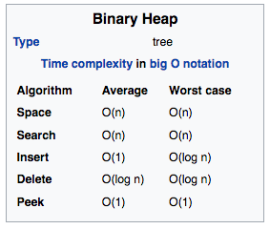

Priority Queue:

Need to implement comparison function (so we can assign the indicator we would like use )
The container defined is:
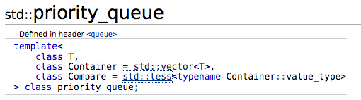
// The entity in this queue
struct puzzle{
int dist=0;
int gn=0;
bool u=false,d=false,l=false,r=false;
string arrayS = "123456870";
};
// The comparison function, use dist in puzzle to compare
struct compare_cost{
bool operator() ( const puzzle& a, const puzzle& b) const{
return a.dist >= b.dist ;
}
};
// Priority queue container, follow the definition above
// puzzle is class, vector is container, compare_cost is comparison function
std::priority_queue<puzzle,vector<puzzle>,compare_cost> q;
Common method:
q.push( class T) // put an entity in to p.q
q.top() // return the entity with maximal distance
q.pop() // erase the entity with the maximal distance
Reference:
[1] STL
http://www.cnblogs.com/Xredman/archive/2009/04/26/1443737.html
[2] Mr. Opengate
http://mropengate.blogspot.com/
[3] vector copy
http://workhahard.blogspot.com/2016/04/c-vector.html
[4] cpp reference
http://www.cplusplus.com/reference/

